1. Go to your web browser and type in redclayschools.schoology.com and Log in using your email and current email password

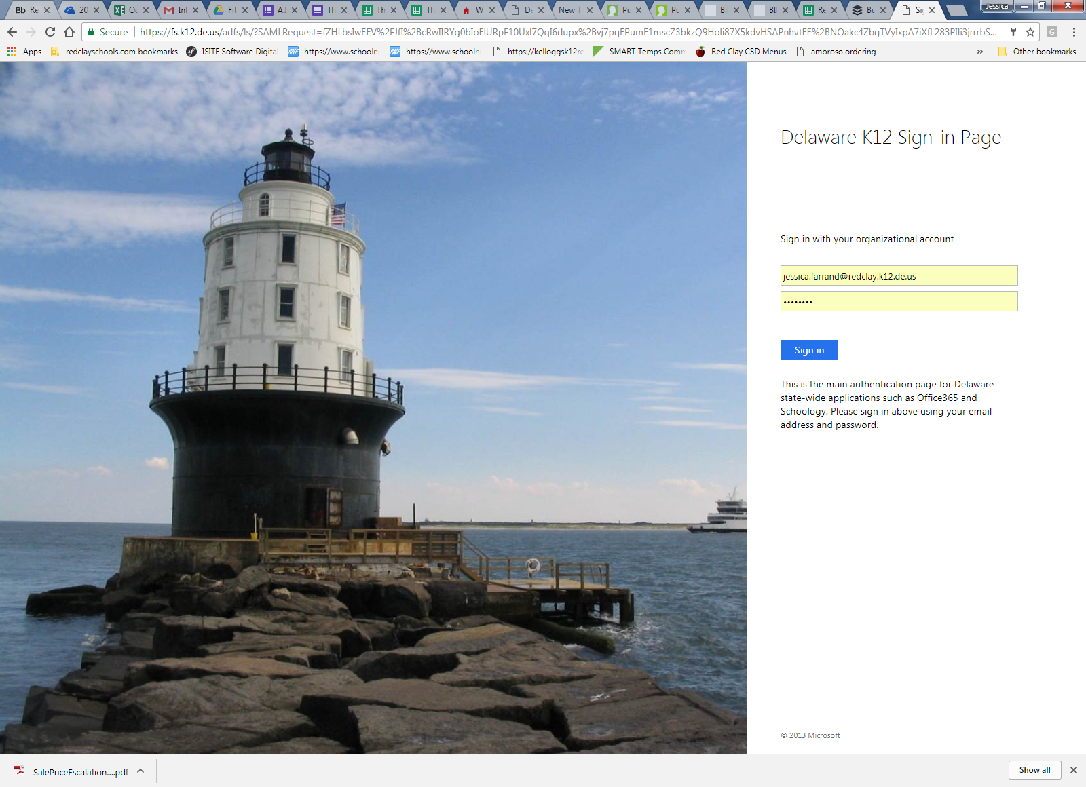

1. Click on the Courses Tab and click “join”

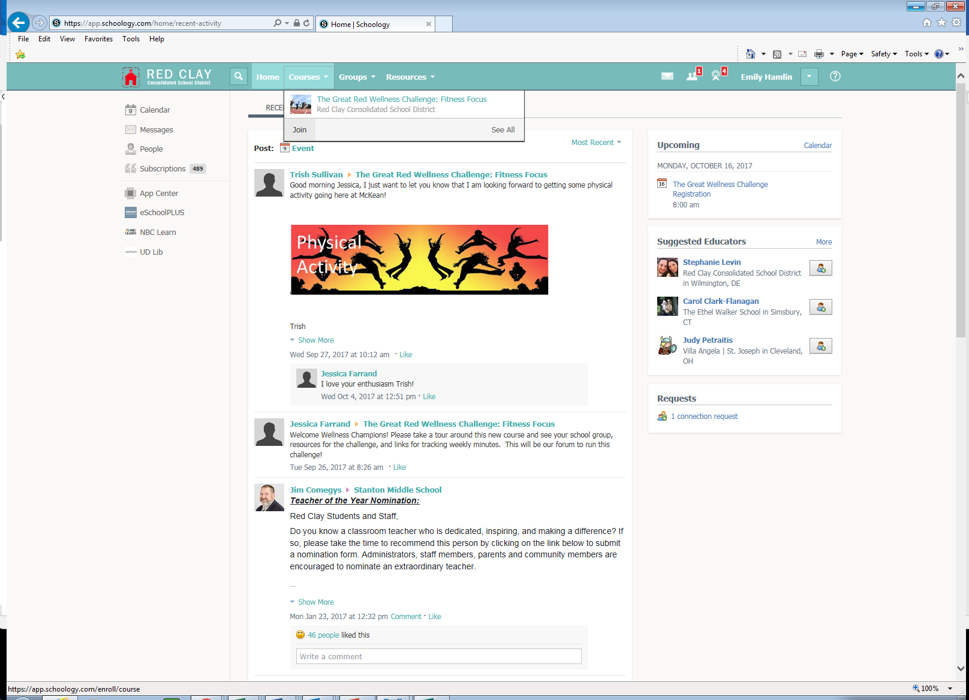

1. Use the Access Code 4R8VF-VNCF3 to join! Then you are able to access course materials on the lefthand side tabs and see calendar events. You will find your tracking logs under course materials

.